1. Problem Description
Sierra Leone has one of the highest maternal mortality ratios in the world. UNFPA reports 354 maternal deaths per 100,000 live births in 2023, down from 443 in 2020, but still far above the SDG 3.1 target of fewer than 70 (UNFPA Sierra Leone, 2025; United Nations, 2015). Many of these deaths can be prevented when a pregnant woman attends her antenatal care (ANC) visits, because complications can be found and treated early.
The community problem addressed here is the lack of a structured way for a clinic to track which pregnant women are due for an antenatal visit, record whether each visit was attended, and follow up on missed visits. In peri-urban communities such as Wilberforce, Goderich and Calabar Town, this follow-up often depends on memory and paper registers, so a missed visit can go unnoticed until a complication appears.
The community problem | Pregnant women miss antenatal visits because there is no structured reminder or tracking process.
Who is affected | Pregnant women and their babies, their families, and community health workers at local clinics.
Why the problem exists | Clinics have no simple, low-cost logical process for scheduling visits, recording attendance and flagging missed visits.
How the solution addresses it | The system schedules a visit every four weeks, records attendance, outputs a reminder for each missed visit and reports a risk level for follow-up.

2. Background
Antenatal care is a series of health check-ups during pregnancy that lets health workers monitor the mother and the baby and detect danger signs early. In 2016 the World Health Organization (WHO) recommended a minimum of eight antenatal contacts, with the first in the first 12 weeks of pregnancy (WHO, 2016). Women may attend fewer visits than recommended, or stop attending after the first visit, because of distance to clinics, cost, limited awareness and the absence of reminders.
This assignment does not build a program. It designs the logic of a reminder system that could later be turned into software. To keep the design clear, the system uses a simplified schedule of one visit every four weeks until week 36. The WHO contact weeks (12, 20, 26, 30, 34, 36, 38 and 40) could replace this fixed interval in a later version.

3. Community Impact
- Problem solved: missed antenatal visits are detected and followed up instead of going unnoticed.
- Expected impact: earlier detection of complications, better attendance, and a risk level (LOW, MEDIUM or HIGH) that helps health workers decide who to follow up first.
- Beneficiaries: pregnant women and newborns, their families, community health workers and the local health system.
- Long-term sustainability: the design has no license cost, can run on a basic computer, a phone or a paper checklist, and can be extended by local developers and students.

4. Proposed Solution
The proposed solution is a Maternal Health Appointment Reminder System operated by a health worker at a clinic. The health worker registers the patient by entering her name, phone number and weeks pregnant. The system then works through each scheduled visit, starting at the entered week and repeating every four weeks until week 36. For each visit it shows the visit number and week, asks whether the patient attended (1 for Yes, 0 for No), and then either confirms attendance or flags the visit as missed and outputs a simulated SMS reminder to her phone number. The SMS is shown as screen output because the design does not include a real SMS service.
When all visits are finished, the system displays a summary with the number of visits attended and missed and a risk level of LOW, MEDIUM or HIGH.

5. Computational Thinking Process
- Decomposition: the problem is split into registration, input validation, the visit loop, the attendance decision, the reminder, the risk level and the summary. Registration and the visit loop are in Main; the other parts are the functions ShowWelcome, SendReminder, GetRiskLevel and DisplaySummary.
- Pattern recognition: every visit follows the same pattern (show the visit, ask for attendance, confirm or remind) and visits are a fixed four weeks apart, so one loop handles all of them.
- Abstraction: clinic names, medical details and real SMS delivery are left out. Only the data needed for tracking is kept: name, phone number, weeks pregnant, visit number and attendance.
- Algorithmic thinking: the logic was written first as a numbered algorithm, then as pseudocode, and then drawn as a flowchart in Flowgorithm (Sections 10 to 12).

6. Algorithm Design
The design uses the following logic structures, all of which appear in the Flowgorithm file Maternal_Health_Reminder.fprg:
- Input, processing and output: input is the name, phone number, weeks pregnant and attendance. Processing counts attended and missed visits and moves to the next visit. Output is the visit details, confirmation or reminder messages, and the summary.
- Decision structures: IF attended equals 1 the visit is confirmed, otherwise it is counted as missed and a reminder is sent. GetRiskLevel uses nested IF/ELSE to choose LOW, MEDIUM or HIGH.
- Repetition structures: a WHILE loop repeats the visit check while weeksPregnant is less than or equal to LAST_WEEK (36). Two more WHILE loops keep asking until the input is valid.
- Boolean logic: the validation conditions use OR and AND, for example weeksPregnant < 1 OR weeksPregnant > LAST_WEEK.
- Modular design: a Main module and four functions, one of which (GetRiskLevel) returns a value. Variables, constants and data types are listed in Section 10.

7. SDG Alignment
The project supports SDG 3: Good Health and Well-being. Target 3.1 aims to reduce the global maternal mortality ratio to fewer than 70 deaths per 100,000 live births by 2030 (United Nations, 2015). By tracking antenatal visits and flagging missed ones, the system helps health workers find women who need follow-up early, which supports this target. It also supports Target 3.8, universal health coverage, because it is a low-cost tool that can help clinics deliver a basic health service more reliably.

8. Open Source Justification
- Why it should be open source: health budgets in Sierra Leone are limited, so a free and open design removes licence costs, can be reviewed and trusted by the communities that use it, and avoids dependence on one vendor.
- Benefits for Sierra Leone: clinics, NGOs and health authorities can use and adapt the design freely, and local students and developers gain experience by improving a real health tool.
- Potential community contributions: developers can turn the design into a mobile or SMS application, medical students and midwives can check the visit schedule against national guidelines, and volunteers can translate messages into Krio and other local languages.
The project files will be published on GitHub under an open licence such as the MIT Licence.

9. Digital Public Goods Justification
A digital public good (DPG) is open-source software, open standards, open data, open AI systems or open content that respects privacy and other applicable laws, does no harm and helps achieve the SDGs (Digital Public Goods Alliance, n.d.).
- How it could become a DPG: the design is open (published on GitHub under an open licence), directly supports SDG 3, keeps only the minimum data needed (name, phone number, weeks pregnant and attendance) and does no harm because it only records attendance and generates reminders. Any future software version would need to protect patient privacy in line with applicable laws.
- Accessibility: the logic can run on low-cost computers, on basic phones through SMS, or as a paper checklist, so it does not depend on smartphones or constant internet access.
- Openness: the report, algorithm, pseudocode and Flowgorithm file are freely available for anyone to copy and improve.
- Public benefit: pregnant women and newborns, among the most vulnerable groups, benefit most, and no one pays to use it.

10. Algorithm

10.1 Data design: variables, constants and data types
Flowgorithm has no separate constant keyword, so VISIT_GAP and LAST_WEEK are variables that are given a value once at the start and never changed. Their names are written in capitals to mark them as constants. Attendance is stored as an Integer (1 = attended, 0 = missed) because it is simple to type at the console.
Name | Data type | Purpose
VISIT_GAP (constant) | Integer | Weeks between visits. Value 4.
LAST_WEEK (constant) | Integer | Last week for scheduled visits. Value 36.
patientName | String | Name of the patient.
phone | String | Phone number used for the reminder.
weeksPregnant | Integer | Current week of pregnancy; increases by VISIT_GAP after each visit.
visitNumber | Integer | Counts the visits, starting at 1.
attended | Integer | Attendance entered by the health worker: 1 = Yes, 0 = No.
attendedCount, missedCount | Integer | Running totals of attended and missed visits.
risk, level | String | Risk level returned by GetRiskLevel and shown by DisplaySummary.

10.2 Main algorithm
START
1. Declare the variables. Set VISIT_GAP = 4, LAST_WEEK = 36, visitNumber = 1, attendedCount = 0 and missedCount = 0.
2. Call ShowWelcome().
3. Input patientName.
4. Input phone.
5. Input weeksPregnant.
6. While weeksPregnant < 1 OR weeksPregnant > LAST_WEEK: output "Invalid weeks. Enter a number from 1 to 36:" and input weeksPregnant again.
7. While weeksPregnant <= LAST_WEEK, repeat steps 8 to 13:
8. Output "Visit [visitNumber] is due at week [weeksPregnant]".
9. Output "Did she attend? Enter 1 for Yes, 0 for No:" and input attended.
10. While attended != 0 AND attended != 1: output "Invalid. Enter 1 for Yes or 0 for No:" and input attended again.
11. If attended = 1: add 1 to attendedCount and output "Appointment confirmed. Well done [patientName]". Otherwise: add 1 to missedCount and call SendReminder(patientName, phone, visitNumber).
12. Set weeksPregnant = weeksPregnant + VISIT_GAP.
13. Set visitNumber = visitNumber + 1, then go back to step 7.
14. Output "All scheduled visits complete."
15. Call DisplaySummary(patientName, phone, attendedCount, missedCount).
STOP

10.3 Function algorithms
ShowWelcome()
1. Output "=== MATERNAL HEALTH APPOINTMENT REMINDER SYSTEM ===".
2. Output "Supporting SDG 3: Good Health and Well-being".
3. Output a line of dashes.
SendReminder(name, phone, visit)
1. Output "MISSED: Visit [visit] flagged for [name]".
2. Output "SMS sent to [phone]: Please visit the clinic as soon as possible."
GetRiskLevel(missed) returns a String
1. If missed = 0, set risk = "LOW".
2. Otherwise, if missed <= 2, set risk = "MEDIUM".
3. Otherwise, set risk = "HIGH - refer to health worker".
4. Return risk.
DisplaySummary(name, phone, attendedTotal, missedTotal)
1. Set level = GetRiskLevel(missedTotal).
2. Output "----------- PATIENT SUMMARY -----------".
3. Output the name, phone number, visits attended, visits missed and risk level.

11. Pseudocode
The pseudocode follows the Flowgorithm file line by line. The & symbol joins text and values, as it does in Flowgorithm, and == and != mean equal to and not equal to.

11.1 Main program
PROGRAM Main
// Constants and variables
DECLARE patientName, phone : String
DECLARE weeksPregnant, visitNumber, attended : Integer
DECLARE attendedCount, missedCount : Integer
DECLARE VISIT_GAP, LAST_WEEK : Integer
SET VISIT_GAP = 4
SET LAST_WEEK = 36
SET visitNumber = 1
SET attendedCount = 0
SET missedCount = 0

CALL ShowWelcome()

// Registration and validation
OUTPUT "Enter patient name:"
INPUT patientName
OUTPUT "Enter phone number:"
INPUT phone
OUTPUT "Enter weeks pregnant (1 to 36):"
INPUT weeksPregnant
WHILE weeksPregnant < 1 OR weeksPregnant > LAST_WEEK DO
OUTPUT "Invalid weeks. Enter a number from 1 to 36:"
INPUT weeksPregnant
END WHILE

// Visit loop: one pass for each antenatal visit
WHILE weeksPregnant <= LAST_WEEK DO
OUTPUT "Visit " & visitNumber & " is due at week " & weeksPregnant
OUTPUT "Did she attend? Enter 1 for Yes, 0 for No:"
INPUT attended
WHILE attended != 0 AND attended != 1 DO
OUTPUT "Invalid. Enter 1 for Yes or 0 for No:"
INPUT attended
END WHILE
IF attended == 1 THEN
SET attendedCount = attendedCount + 1
OUTPUT "Appointment confirmed. Well done " & patientName
ELSE
SET missedCount = missedCount + 1
CALL SendReminder(patientName, phone, visitNumber)
END IF
SET weeksPregnant = weeksPregnant + VISIT_GAP
SET visitNumber = visitNumber + 1
END WHILE

OUTPUT "All scheduled visits complete."
CALL DisplaySummary(patientName, phone, attendedCount, missedCount)
END PROGRAM

11.2 Functions
FUNCTION ShowWelcome()
OUTPUT "=== MATERNAL HEALTH APPOINTMENT REMINDER SYSTEM ==="
OUTPUT "Supporting SDG 3: Good Health and Well-being"
OUTPUT "----------------------------------------------"
END FUNCTION

FUNCTION SendReminder(name : String, phone : String, visit : Integer)
OUTPUT "MISSED: Visit " & visit & " flagged for " & name
OUTPUT "SMS sent to " & phone & ": Please visit the clinic as soon as possible."
END FUNCTION

FUNCTION GetRiskLevel(missed : Integer) RETURNS String
DECLARE risk : String
IF missed == 0 THEN
SET risk = "LOW"
ELSE
IF missed <= 2 THEN
SET risk = "MEDIUM"
ELSE
SET risk = "HIGH - refer to health worker"
END IF
END IF
RETURN risk
END FUNCTION

FUNCTION DisplaySummary(name : String, phone : String, attendedTotal : Integer, missedTotal : Integer)
DECLARE level : String
SET level = GetRiskLevel(missedTotal)
OUTPUT "----------- PATIENT SUMMARY -----------"
OUTPUT "Name: " & name
OUTPUT "Phone: " & phone
OUTPUT "Visits attended: " & attendedTotal
OUTPUT "Visits missed: " & missedTotal
OUTPUT "Risk level: " & level
END FUNCTION

12. Flowcharts
The flowcharts were built in Flowgorithm, a free flowchart tool, and are saved in the file Maternal_Health_Reminder.fprg in the GitHub repository. The file contains five flowcharts: Main and the four functions. They match the algorithm in Section 10 and the pseudocode in Section 11.
Flowchart element | Used for | Example in this design
Start / End | Begin and finish each flowchart | Main, ShowWelcome, SendReminder, GetRiskLevel, DisplaySummary
Declare / Assign | Create variables and change values | VISIT_GAP = 4; weeksPregnant = weeksPregnant + VISIT_GAP
Input | Read data from the health worker | Input patientName; Input attended
Output | Show prompts and results | Output "Appointment confirmed. Well done " & patientName
If (decision) | Choose between two paths | attended == 1; missed == 0
While (loop) | Repeat while a condition is true | weeksPregnant <= LAST_WEEK
Call | Run another module | Call SendReminder(patientName, phone, visitNumber)

SCREENSHOT OF THE MAIN MODULE IN THE FLOWGORITHM APP:
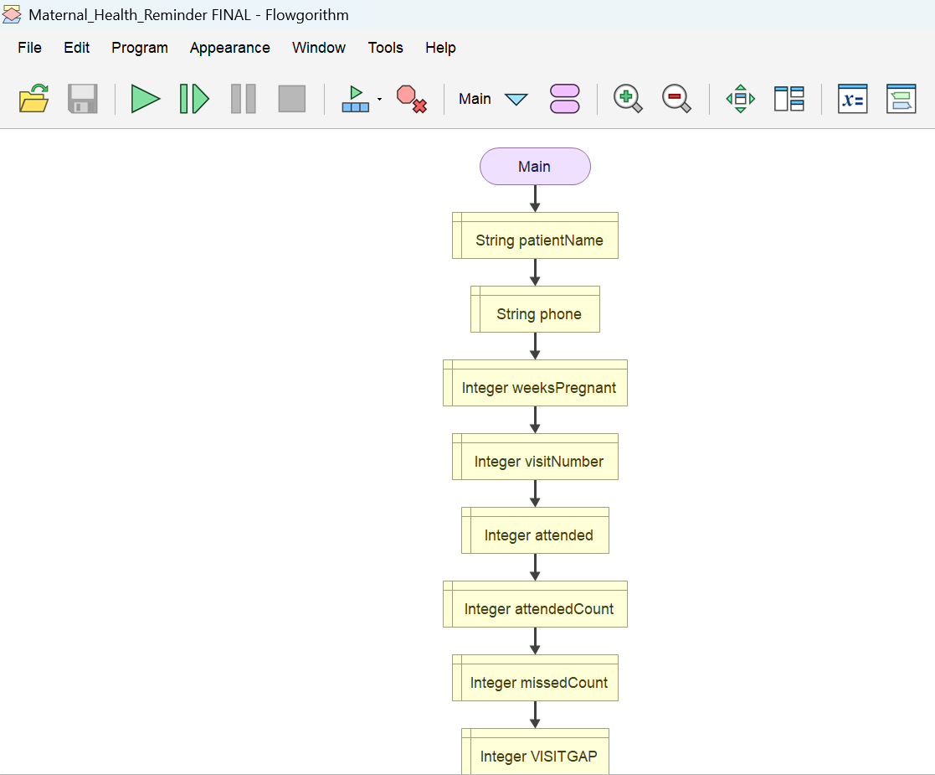

13. Functional Modules
The system is divided into one control module (Main) and four functions. This is the problem decomposition: each module does one job and can be tested on its own.
Module | Purpose | Parameters and return | Logic used
Main | Registers the patient, validates input, runs the visit loop, counts attended and missed visits and calls the other modules. | No parameters. | Sequence, three WHILE loops, IF/ELSE, Boolean conditions
ShowWelcome | Displays the system title and the SDG 3 line. | No parameters; no return value. | Sequence
SendReminder | Flags a missed visit and outputs the simulated SMS reminder. | name: String, phone: String, visit: Integer. No return value. | Sequence, text joining
GetRiskLevel | Converts the number of missed visits into a risk level. | missed: Integer. Returns a String. | Nested IF/ELSE
DisplaySummary | Calls GetRiskLevel and outputs the patient summary. | name: String, phone: String, attendedTotal: Integer, missedTotal: Integer. No return value. | Function call with a returned value

13.1 Risk level rules
Visits missed | Risk level returned by GetRiskLevel
0 | LOW
1 or 2 | MEDIUM
3 or more | HIGH - refer to health worker

13.2 How the modules call each other
Main
CALL ShowWelcome()
CALL SendReminder(patientName, phone, visitNumber) // once for each missed visit
CALL DisplaySummary(patientName, phone, attendedCount, missedCount)
CALL GetRiskLevel(missedTotal)

14. Expected Outputs
Four sample scenarios show the expected outputs. Each transcript is exactly what the Flowgorithm file displays for the inputs shown, with the typed inputs in bold. All patient names and phone numbers are fictional test data.
Scenario | What it shows | Risk level
1. All visits attended | Five visits from week 20, all attended. | LOW
2. Two visits missed | Three visits from week 28, two missed with reminders. | MEDIUM
3. Three visits missed | Four visits from week 24, three missed with reminders. | HIGH - refer to health worker
4. Invalid input | Weeks entered as 50 and attendance as 5 are rejected and asked again. | MEDIUM

14.1 Scenario : Invalid input is rejected
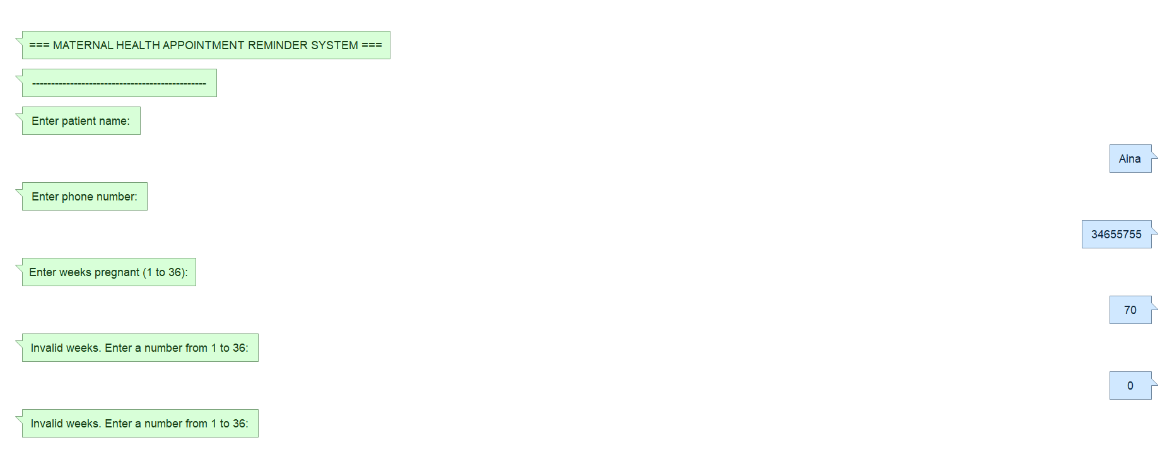

15. GitHub Evidence
The project is stored in a GitHub repository that shows regular commits made during development. The repository name follows the required convention:
PROG101_Assignment1__Aina B.C.E Davies_905006600
Repository URL | https://github.com/ainadavies482-sudo/PROG101_ASSIGNMENT1_AINA_B.C.E_DAVIES_905006600_BIT1101F_SEMESTER1

SCREENSHOT OF GUITHUB REPOSITORY:

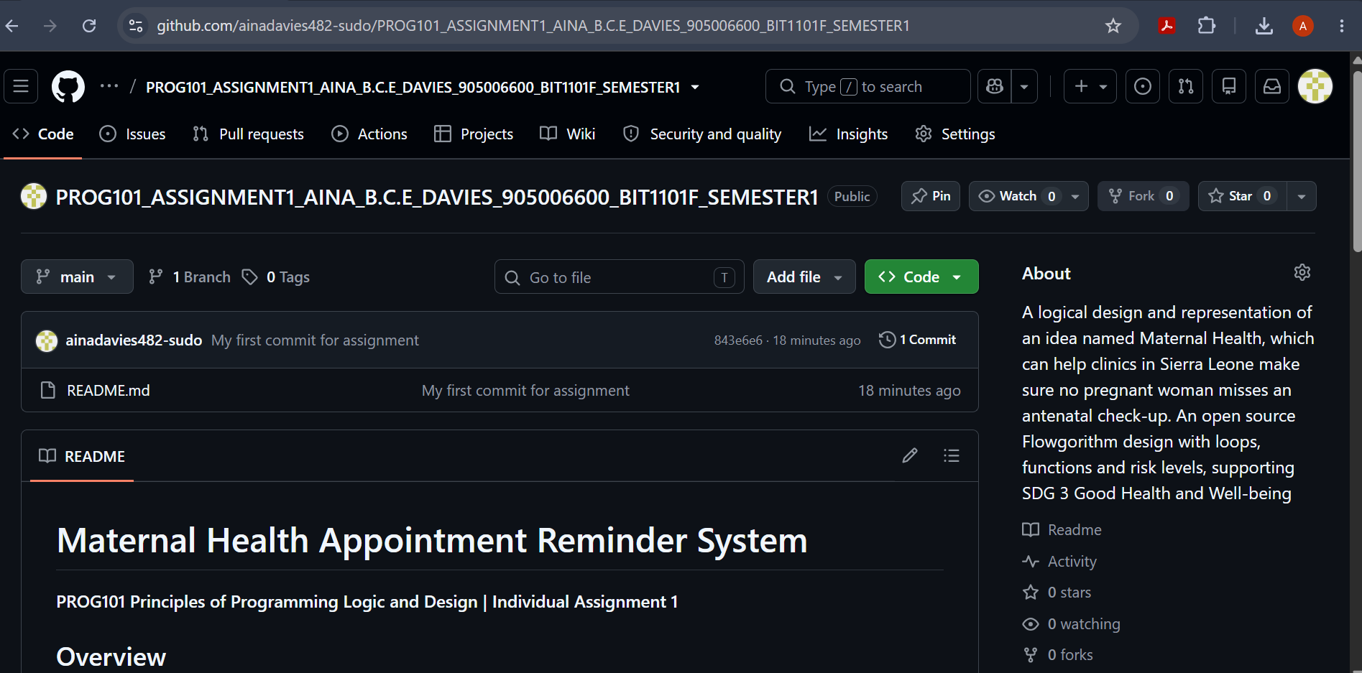

SCREENSHOT OF GIT COMMIT HISTORY:

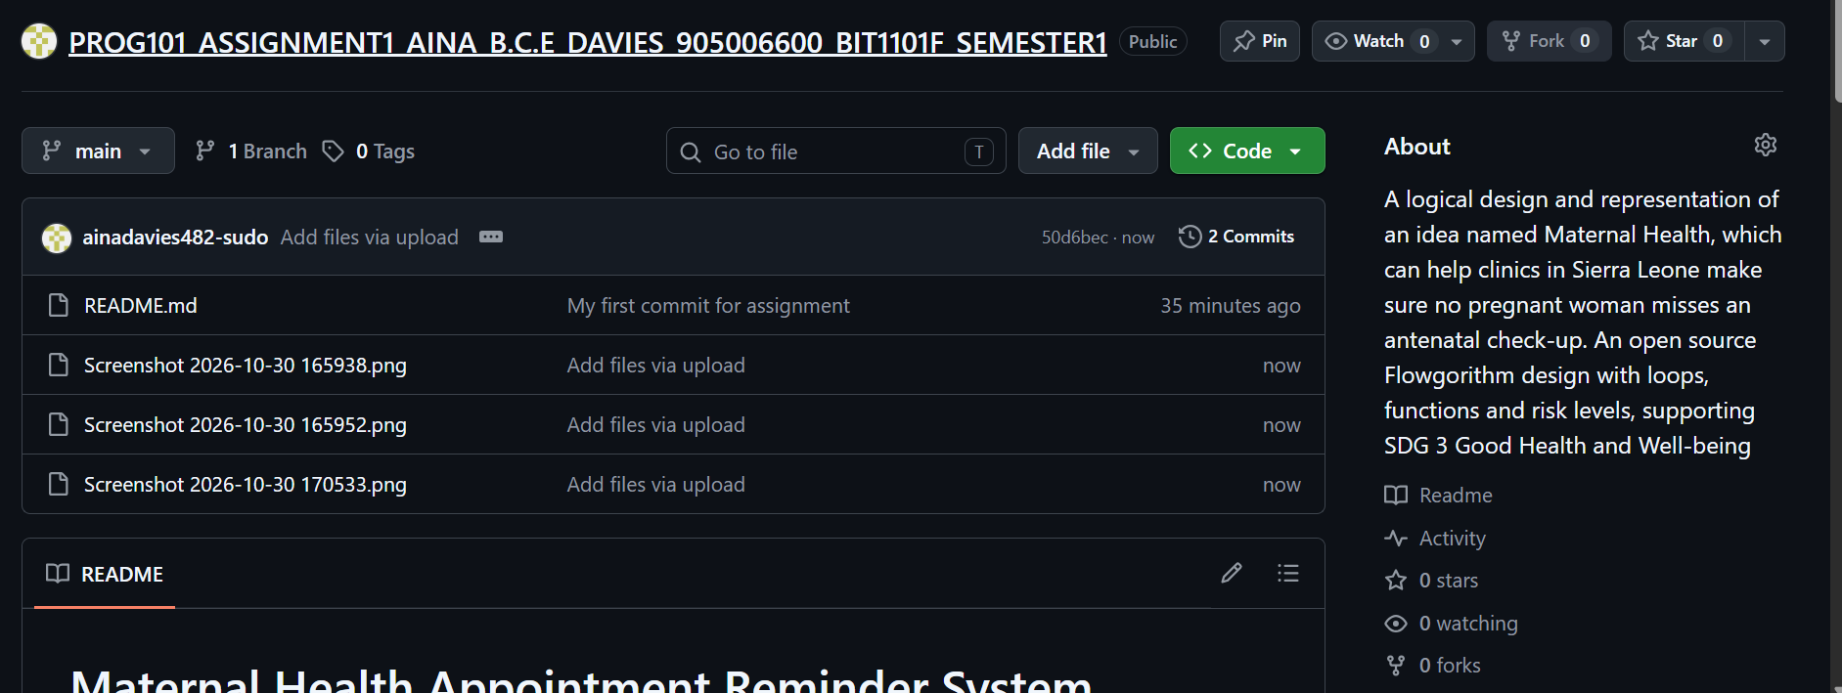

SCREENSHOT OF THE READ ME:
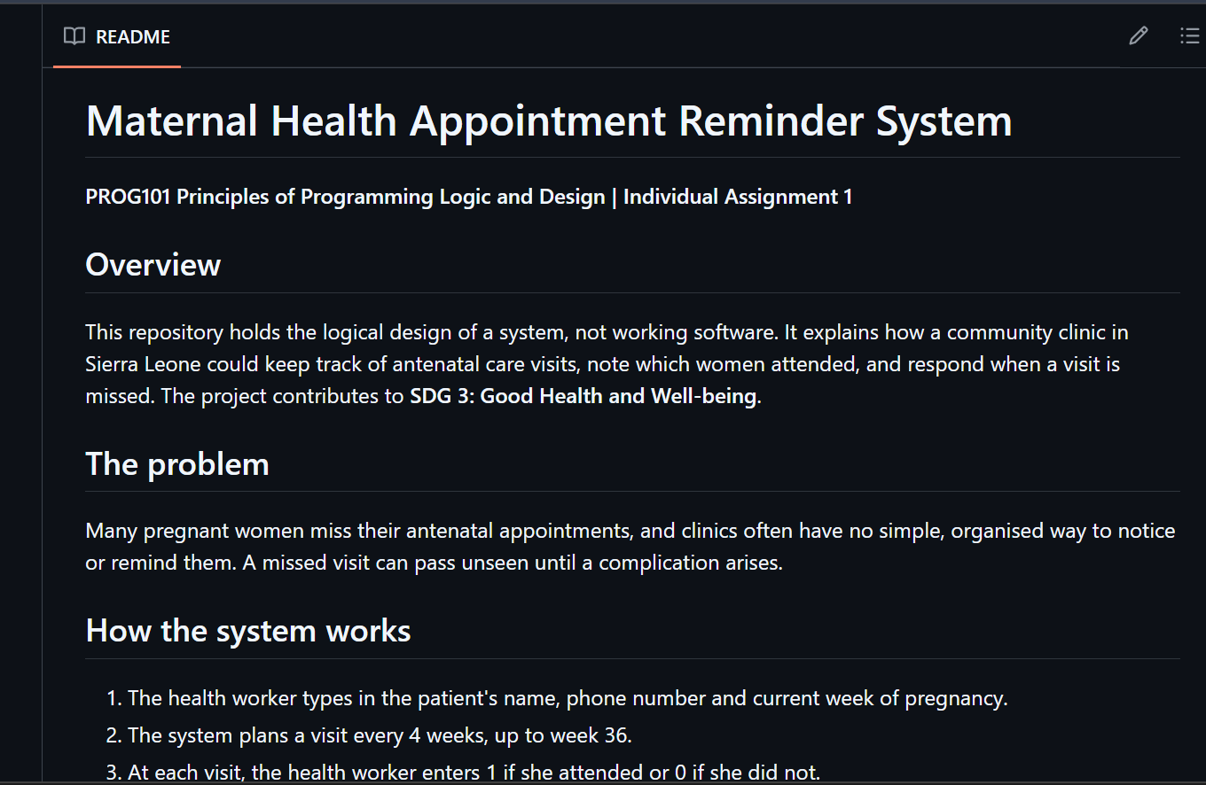

16. References

Cook, D. (n.d.) Flowgorithm: flowchart programming language. Available at: http://www.flowgorithm.org (Accessed: 26 October 2026).

Digital Public Goods Alliance (n.d.) Digital public goods. Available at: https://digitalpublicgoods.net/digital-public-goods (Accessed: 26 October 2026).

UNFPA Sierra Leone (2025) Sierra Leone’s maternal mortality ratio declines, 7 April. Available at: https://sierraleone.unfpa.org/en/news/sierra-leones-maternal-mortality-ratio-declines-unfpa-launches-midwifery-accelerator-tackle (Accessed: 26 October 2026).

United Nations (2015) Transforming our world: the 2030 Agenda for Sustainable Development. New York: United Nations.

World Health Organization (2016) WHO recommendations on antenatal care for a positive pregnancy experience. Geneva: World Health Organization.

